**Kalfas Prek 3 Supply List**

**The supplies we are asking for will carry us through the school year. 😊**

* Two complete changes of clothing – include shirts, pants, socks, and underwear. **Place clothes in a gallon sized Ziplock bag with your child’s name written on it.**  This is how we will store your child’s clothing throughout the year.
* A **full-sized backpack** with your child’s name on it (please no wheels or miniature preschool size ones).
* A resting blanket (no kinder-mats). We will wash these once a week in school.
* **3** bottles of hand sanitizer -the class will use these multiple times during the day. The larger the bottle the better!
* **3** boxes of Kleenex- this we will ask again for as needed.
* **3** bottles of Lysol All-Purpose Cleaner (it’s the yellow spray bottle), or Lysol wipes.

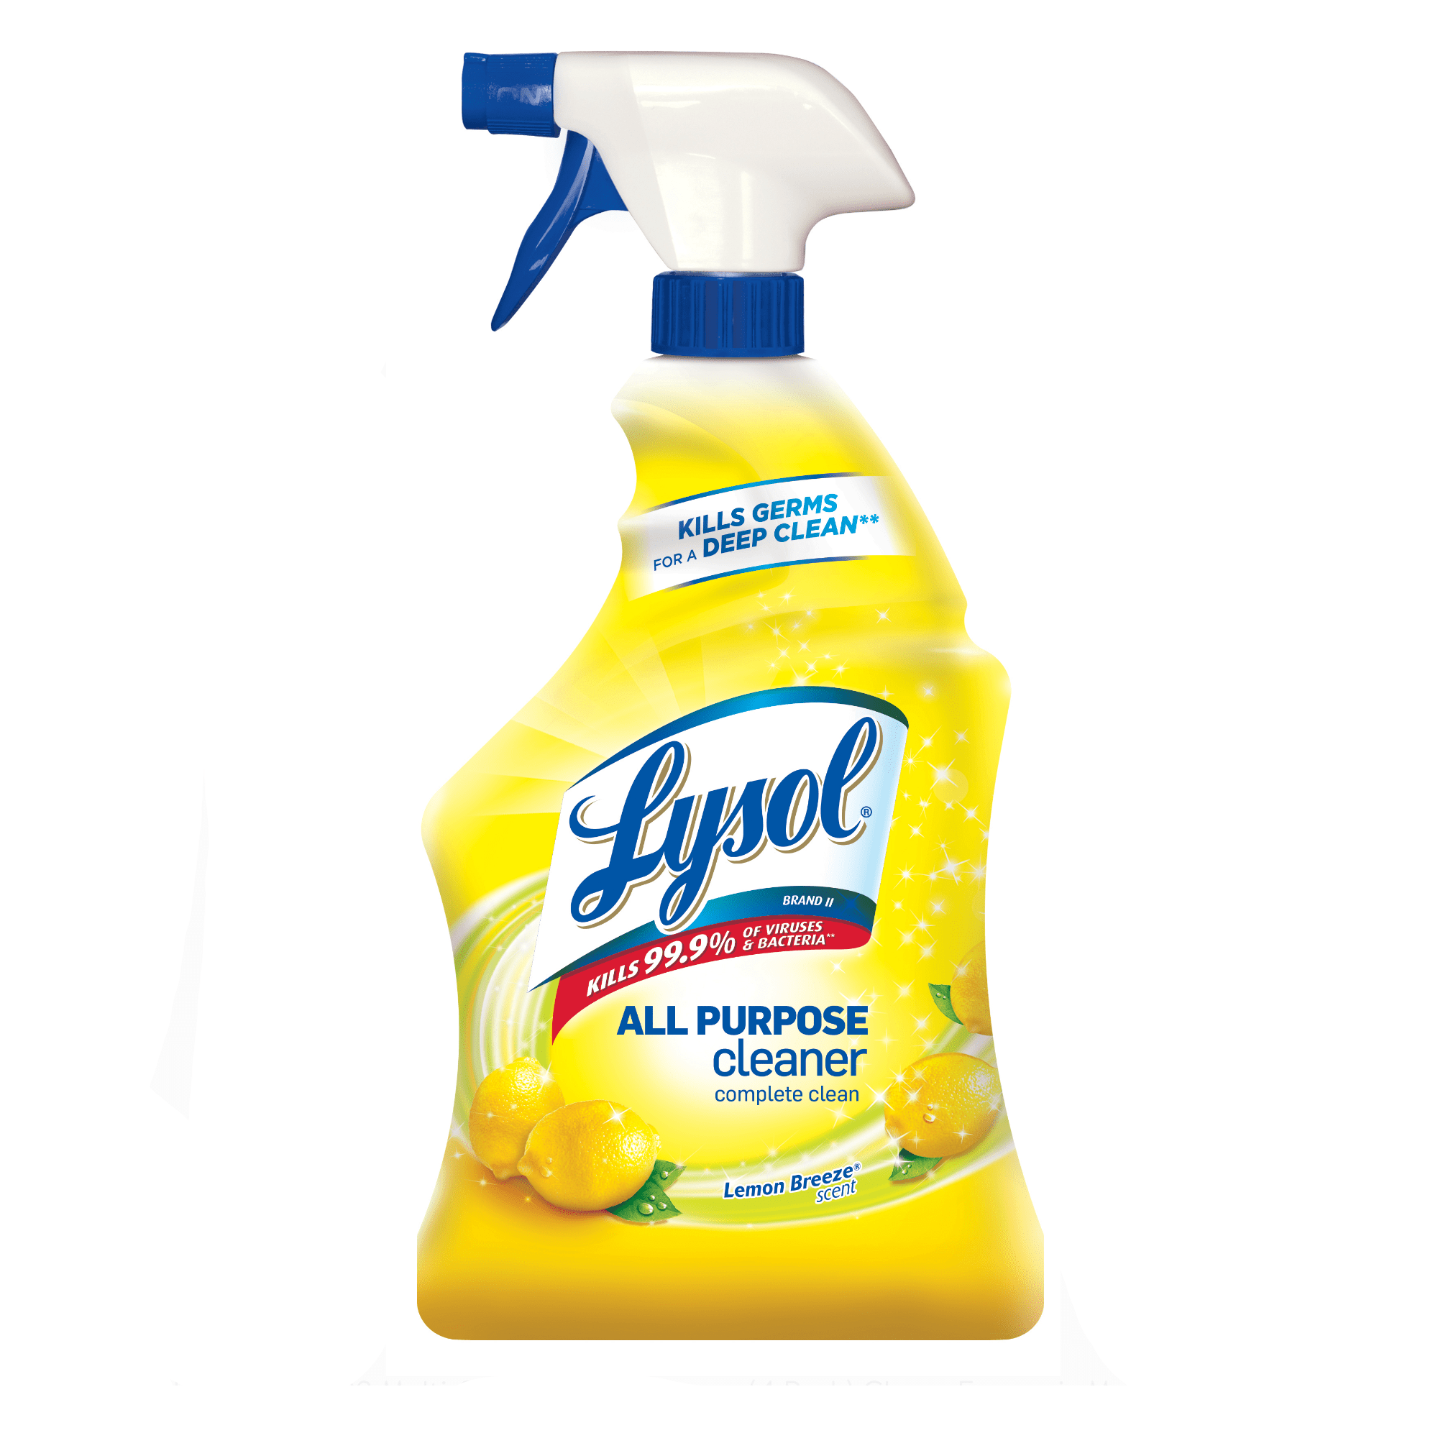or 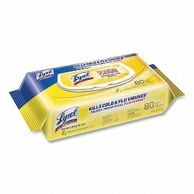

* **2** boxes of **Crayola** Crayons to create the most beautiful artwork! We would like the box of 8 big crayons – **not** the box of 24 please.

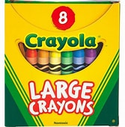

* **2** bottles of **Elmer** Glue 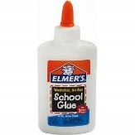

We ask for certain brands of supplies, because we know they will last the duration of the school year, and work the best. Thank you in advance for sending in the supplies for your child.

Each and every supply will be used, some to keep us healthy and some to help us grow!